7.13.1 Pending Invoice Maintenance
We use this function for maintance sales orders before their real invoicing (invoices, credit and debit notes).
By this function we can change/set the prices and the Qties to be issued/invoiced.
This function is kind of 7.1.1, looks very similar. The only difference is that the Qties means the units, which have been already confirmed by our warehouse and will be invoiced accordingly.

Example:
7.1.1 = 1.000m 101000XG0022100 (customer ordered 1.000m)
7.13.1 = 980m 101000XG0022100 (our warehouse confirmed 980m – because of shorter rolls)
7.13.3 = 980m 101000XG0022100 (will be invoiced)

7.13.3 check what everything is there to be invoiced (means already confirmed sales orders by our warehouse – you can sort it by sales order number, Sold to party, etc.)
We need to add the carriage and comment to be displayed on the final invoice.
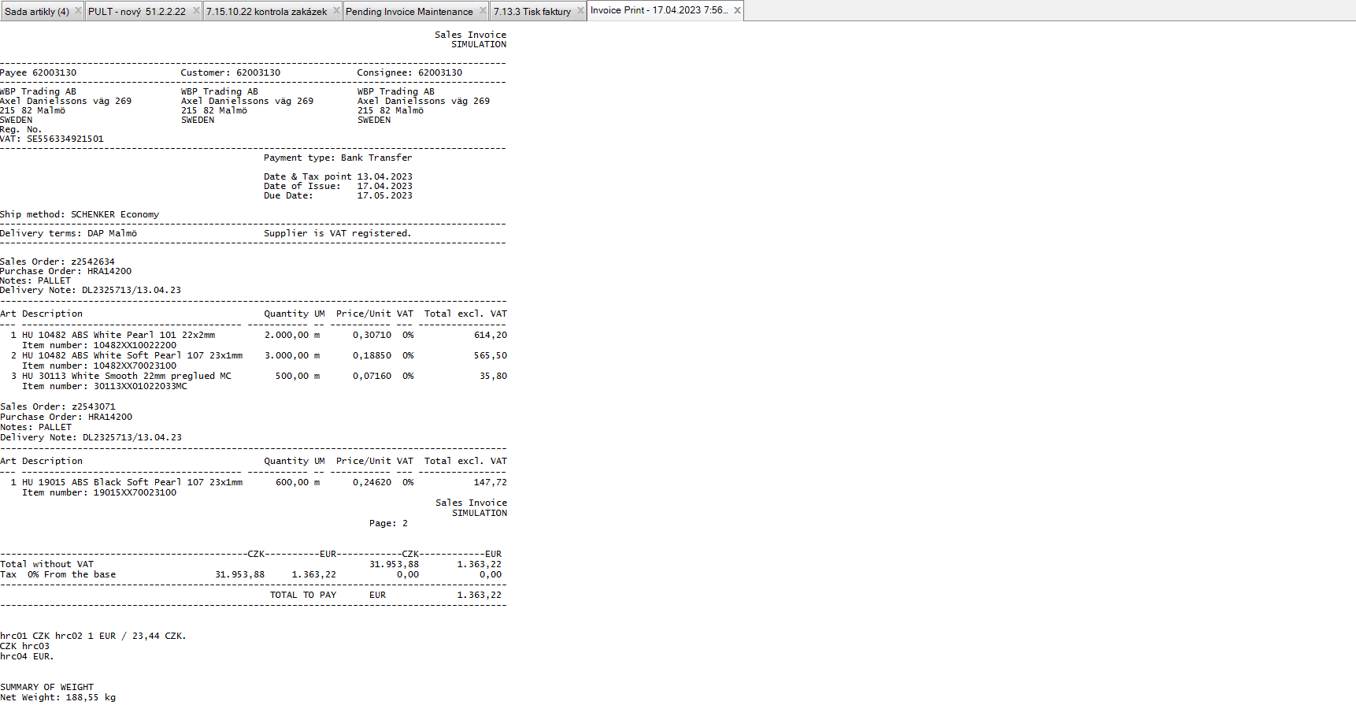

7.13.1 enter one of sales order number from the list from 7.13.3 (usually we use the first or the last one, depends on you)
Reprice – click the box to be able to change the Qties and the prices
+ few times Next
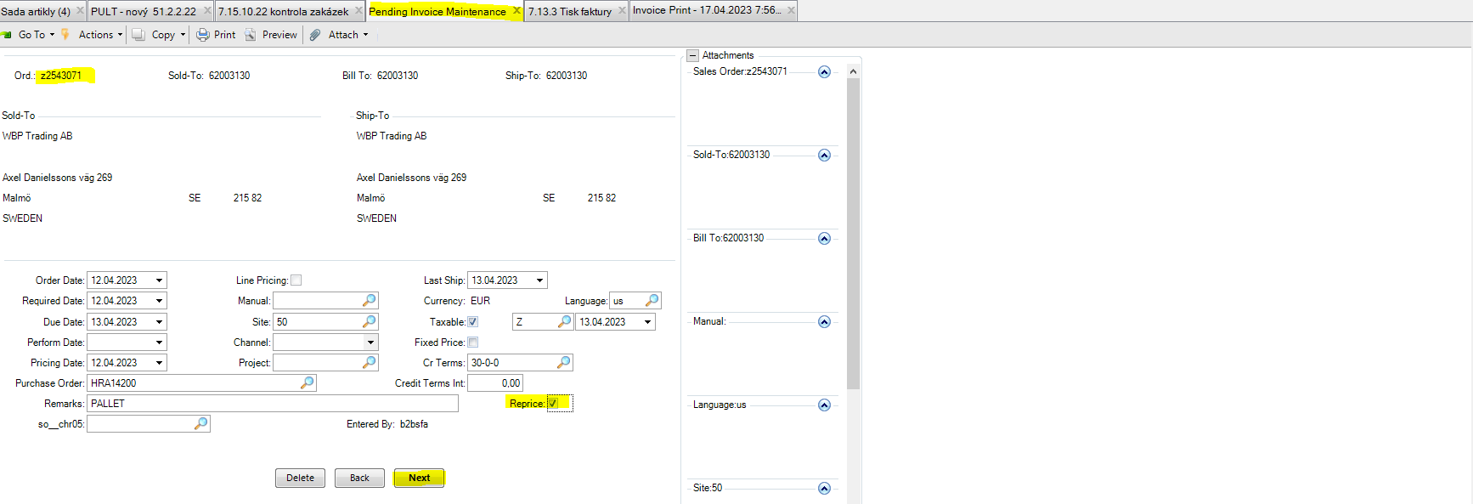
Comments – click the box to be able to write comments to be displayed on the final invoice.
+ few times Next
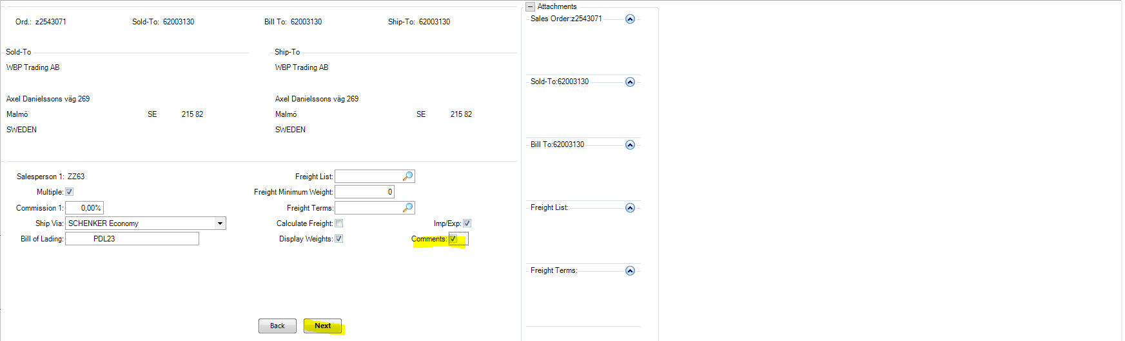

Write down the comment if you need (usually we use it to inform client about number of the pallets and gross weight)
+ few times Next
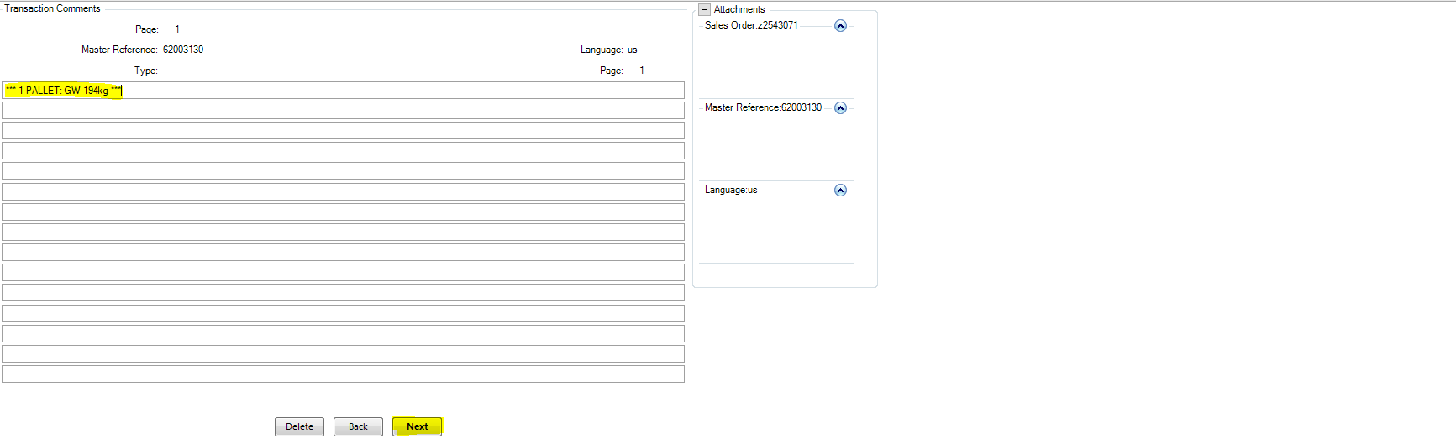

Print On Invoice - click the box to see your comment on the invoice
+ few Next + Back
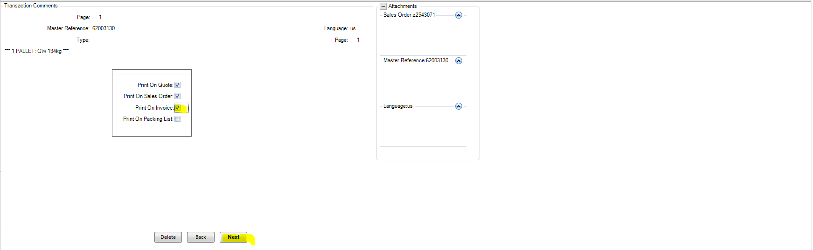

Close comment maintenance – Yes
+ Next
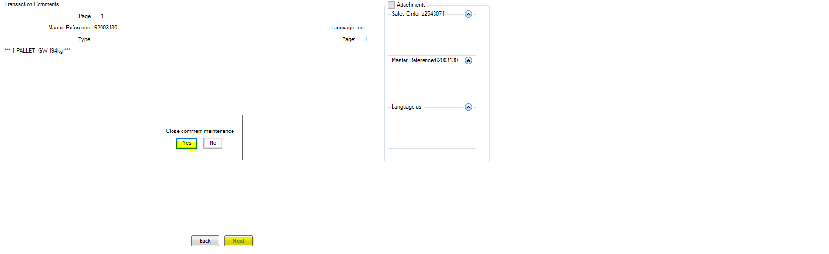

Now you are on item number level. It works the same as in 7.1.1.
By using Line you can display each position.
By adding a new line you can add a new positions, e.g. carriage.
+ few times Back + few times Next
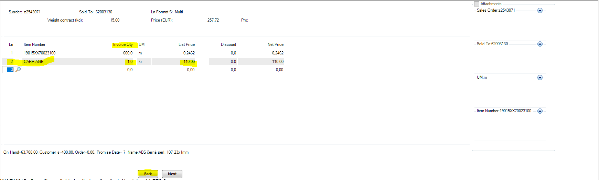

View/Edit import/export data – NO (and the maintenance is finished)
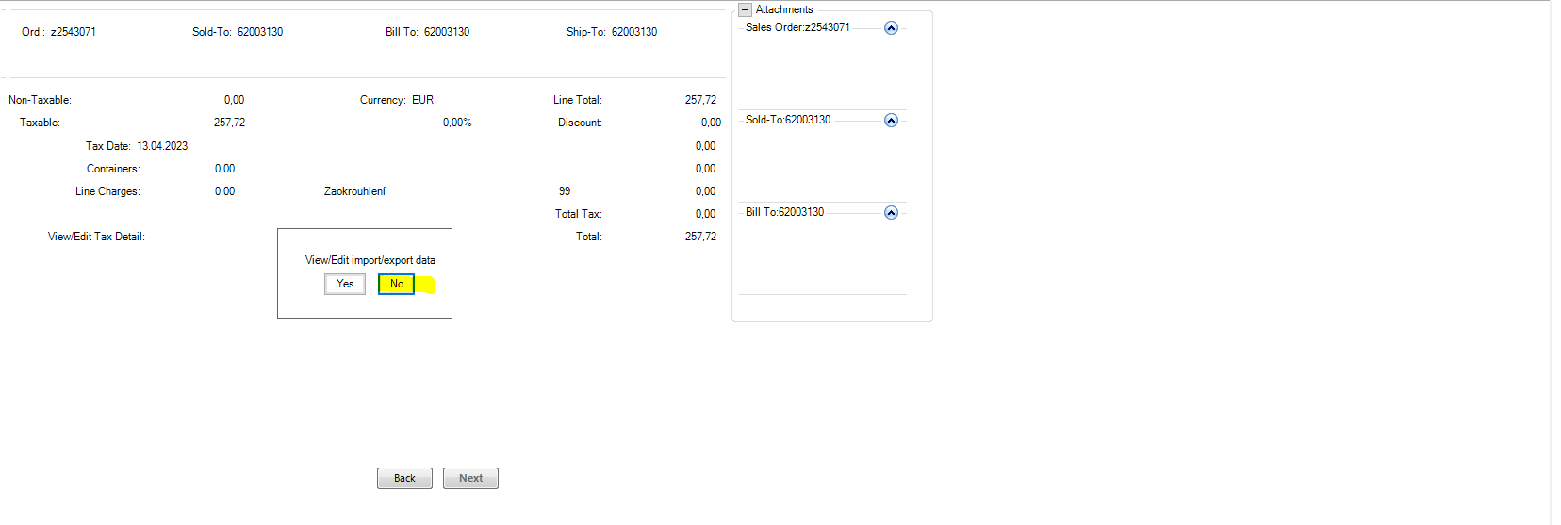
7.13.3 use again to see if the new maintenance was saved correctly
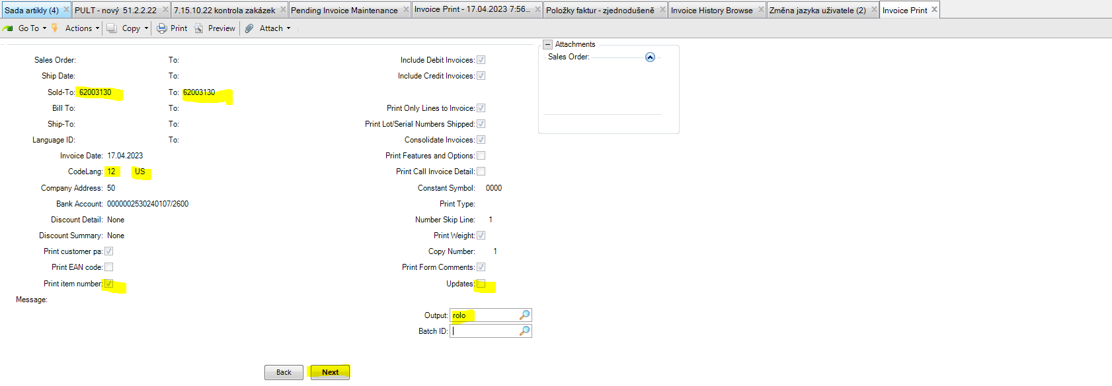
7.13.3 shows now that there is newly the carriage and the comment.
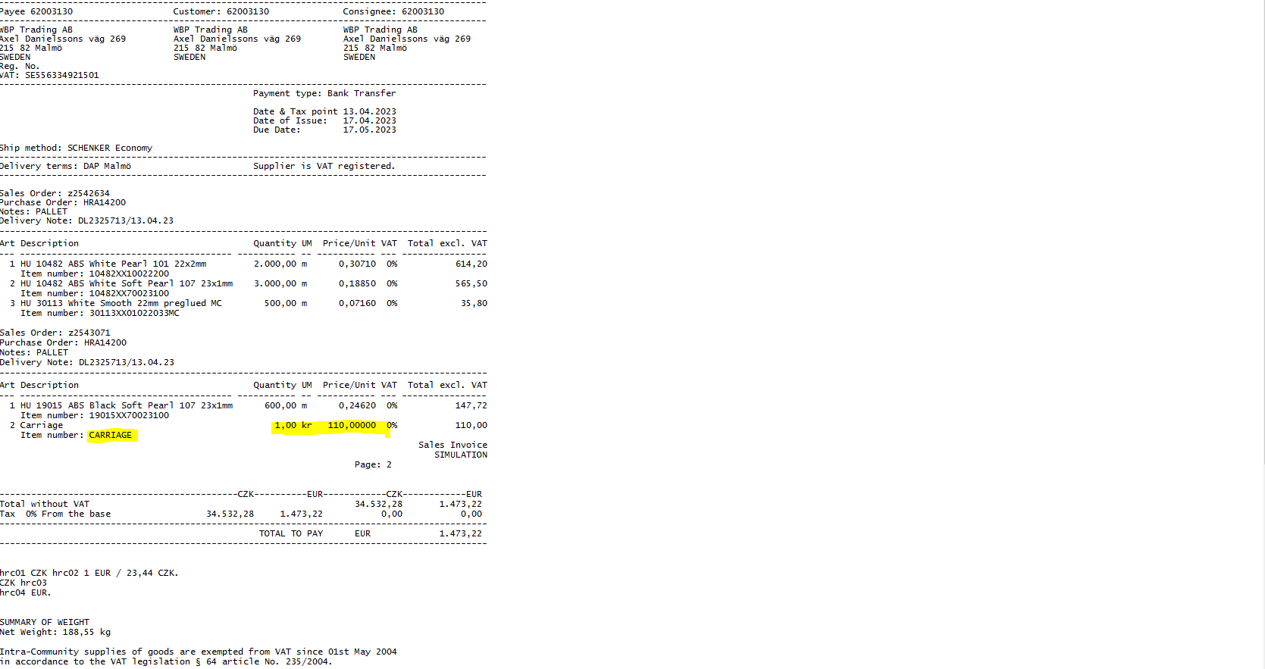

7.13.3 lets issue the invoice by using below settting
Print Weight – to display a netto weight on the invoice = click the box
+ Next
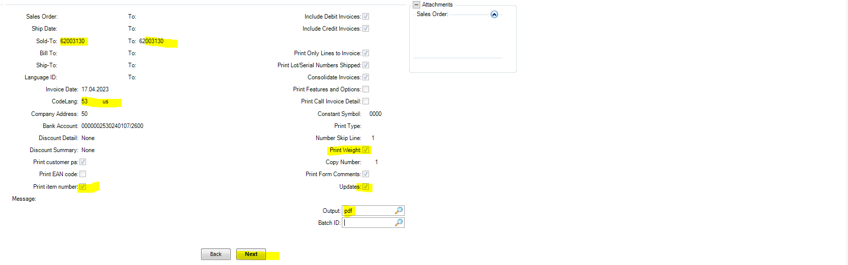

You should receive the invoice to your mailbox in a while.

Now you can also see in 51.2.2.22 the number of invoice.
After the invoice is posted in QAD, all the lines dissapear from this report. Then the business case is closed … Only the customer needs to pay the invoice within their payment terms, of course. :-D
